Interested in a Camp Jags t-shirt?

T-Shirts will be available to purchase for $10.
The color of the shirts will be bright orange with white lettering and a navy blue jaguar paw print.
The design is pictured.

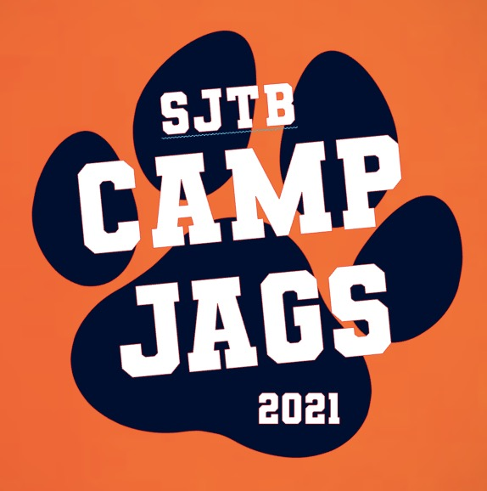
Cash and checks will be accepted.
Make checks payable to: St. John the Baptist Catholic School.

Please have order forms turned in by May 1.

- - - - - - - - - - - - - - - - - - - - - - - - - - - - - - - - - - - - - - - - - - - - - - - - - - - - - - - - - - - - -

Child’s Name: ________________________________
Child’s Age: ________________________________
Parent’s Name: ________________________________
Parent’s Phone: ________________________________
Parent’s Email: ________________________________

T- Shirt Color: Orange  Lettering: White | Size | Price | Quantity | Amount Total
Adult | XS S M L XL | $10.00
Youth | XS S M L XL | $10.00

Total Quantity: ________ Total Amount: ________

